insert into [Type_Service] ([Type_Service_Name], [Date_Time_Event])

values ('На открытой местности','1998-05-02 01:23:56.123'),

('На закрытой местности','1998-05-02 01:23:56.123'),

('На открытой местности','2010-05-02 01:23:56.123'),

('На открытой местности','2023-05-02 01:23:56.123')

go

select [Type_Service_Name] as "Название типа услуги", [Date_Time_Event] as "Время проведения" from [Type_Service]

order by [Type_Service_Name] ASC

go

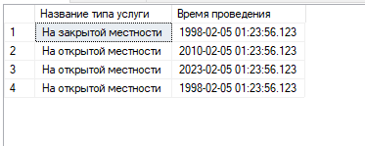

insert into [Country]

values ('Швейцария'),

('Россия'),

('Казахстан'),

('Америка')

go

select [Country_Name] as "Название страны" from [Country]

order by [Country_Name] ASC

go

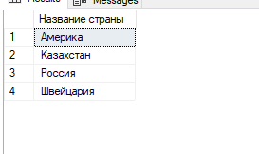

insert into [Market_Place] ([Market_Address], [Country_ID])

values ('ул. дрозд, д.5, стр. 1', 1),

('ул. Вильнюсская, д.3, к.2', 2),

('ул. Айтихабово, д.0, к.0', 3),

('ул. Вильнюсская, д.2, к.1', 4)

go

select [Market_Address] from [Market_Place]

order by [Market_Address] ASC

go

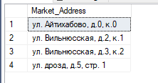

insert into [Payment_Type] ([Name_Payment_Type])

values ('Наличный'),

('Без наличный'),

('какой-то ещё'),

('И ещё какой-то')

go

select [Name_Payment_Type] from [Payment_Type]

order by [Name_Payment_Type] ASC

go

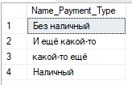

insert into [Position] ([Name_Position])

values ('Инструктор'),

('Бухгалтер'),

('кто-то'),

('ещё кто-то')

go

select [Name_Position] as "Должность" from [Position]

order by [Name_Position] ASC

go

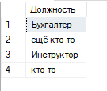

insert into [Worker] ([First_Name], [Second_Name], [Middle_Name], [Key_Worker], [Login_Worker], [Password_Worker])

values ('П','П','П','NVERL','PPP','ppp'),

('Д','Д','Д','ERRFL','DDD','ddd'),

('О','О','О','PREPV','OOO','ooo'),

('И','И','И','VKRLV','III','iii')

go

select [First_Name]+' '+[Second_Name]+' '+[Middle_Name] as "FIO" , [Key_Worker] , [Login_Worker],

[Password_Worker] from [Worker]

order by [First_Name] ASC

go

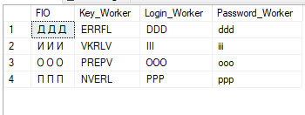

insert into [Client] ([First_Name_Client], [Second_Name_Client], [Middle_Name_Client], [Login_Client], [Password_Client])

values ('Г','Г','Г','ГГГ','ггг'),

('Ж','Ж','Ж','ЖЖЖ','жжж'),

('П','П','П','ППП','ппп'),

('А','А','А','ААА','ааа')

go

select [First_Name_Client]+' '+[Second_Name_Client]+' '+[Middle_Name_Client] as "FIO", [Login_Client] as "LOG", [Password_Client] as "PAS" from [dbo].[Client]

order by [Login_Client] ASC

go

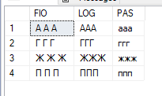

alter table [Cancellation] alter column [Date_Create_Cncll] [date] null

go

alter table [Cancellation] add constraint [DT_Date_Create_Cncll] default(getdate()) for [Date_Create_Cncll]

go

insert into [Cancellation] ([Cancellation_Number])

values ('0001'),

('0002'),

('0003'),

('0004')

go

select [Cancellation_Number] as "Number", [Date_Create_Cncll] as "Date" from [Cancellation]

order by [Date_Create_Cncll] DESC

go

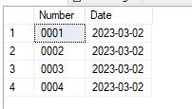

alter table [Maker] add constraint [UQ_Name_Maker] unique ([Maker_Name])

go

insert into [Maker] ([Maker_Name], [Country_ID])

values ('Arsenal',1),

('Strike Active',2),

('АНКО',3),

('Airsoftstore',4)

Go

select [Maker_Name] as "Name", [Country_Name] as "Country" from [Maker]

inner join [Country] on [Country_ID] = [ID_Country]

order by [Country_Name] ASC, [Maker_Name] DESC

go

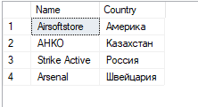

insert into [Warehouse] ([Warehouse_Address], [Market_Place_ID])

values ('ул. Вильнюсская, д.2, стр. 3', 4),

('ул. Голубинская, д.1, стр. 2', 5),

('ул. Тарусская, д.1, стр. 3', 6),

('ул. Айтихаб, д.5, к.4', 7)

go

select [Warehouse_Address] as "Address" from [Warehouse]

order by [Warehouse_Address] ASC

go

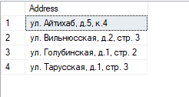

insert into [Contractor] ( [Full_Name_Contractor], [Short_Name_Contractor],

[Legal_Address_Contractor], [Physical_Address_Contractor], [Contractor_E_Mail], [Contractor_Phone_Number],

[BIC], [ITN], [ARCoEaO])

values ( '"Первый"', '"П"', 'ул. Арбат, д1',

'ул. Арбат, д3', 'Pervi@mail.ru', '+7(495)456-11-11',

'35674316', '396652867052', '4824096316'),

( '"Второй"', '"В"', 'ул. Лубянская, д4',

'ул. Лубянская, д4', 'Vtoroi@mail.ru', '+7(495)456-22-22',

'29665123', '583349957123', '4995123385'),

( '"Третий"', '"Т"', 'ул. Болотная, д3',

'ул. Болотная, д3', 'Treti@mail.ru', '+7(495)456-33-33',

'83128904', '679333078641', '6722450097'),

( '"Четвёртный"', '"Ч"', 'ул. Ясногорская, д4',

'ул. Ясногорская, д4', 'Chetverti@mail.ru', '+7(495)456-44-44',

'3458325', '342853590395', '9324589374')

Go

select [Full_Name_Contractor], [Short_Name_Contractor], [Legal_Address_Contractor], [Physical_Address_Contractor],

[Contractor_E_Mail], [Contractor_Phone_Number], [BIC], [ITN], [ARCoEaO] from [Contractor]

order by [Full_Name_Contractor] ASC

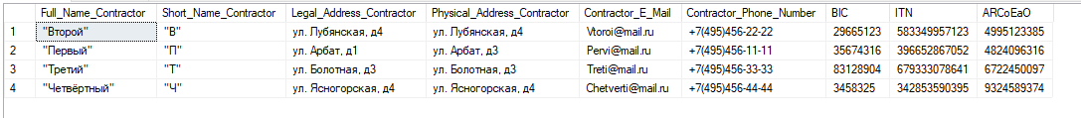

insert into [Representative] ([Contractor_ID], [First_Name_Representative], [Second_Name_Representative], [Middle_Name_Representative])

values (1,'Р','Р','Р'),

(2,'К','К','К'),

(3,'В','В','В'),

(4,'Г','Г','Г')

go

select * from [Representative]

order by [ID_Representative]

go

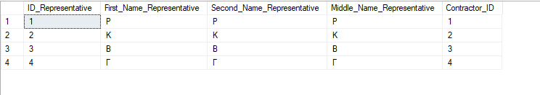

insert into [Treaty] ([Treaty_Number], [Urgent], [Term], [Representative_ID])

values ('0001','+','7 лет',1),

('0002','+','4 года',2),

('0003','+','5 лет',3),

('0003','+','5 лет',4)

go

select * from [Treaty]

order by [ID_Treaty]

go

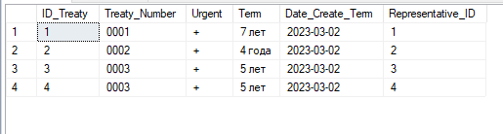

alter table [Client_Card] add [Card_Number] [varchar] (19) not null, constraint [UQ_Card_Number] unique ([Card_Number]),

constraint [CH_Card_Number] check ([Card_Number] like '[0-9][0-9][0-9][0-9] [0-9][0-9][0-9][0-9] [0-9][0-9][0-9][0-9] [0-9][0-9][0-9][0-9]')

go

insert into [Client_Card] ([Card_Number], [Card_Holder], [Validity], [Client_ID])

values ('2245 5367 7642 7640','III','01/14',1),

('5542 5674 9974 8974','GGG','11/23',2),

('8444 8854 1178 9942','VVV','14/22',3),

('4566 4567 3354 5676','KKK','11/27',4)

go

select * from [Client_Card]

order by [ID_Client_Card]

go

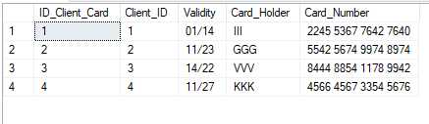

insert into [Connection] ([Position_ID], [Worker_ID])

values (1,1),

(2,2),

(3,3),

(4,4)

go

select * from [Connection]

order by [ID_Connection]

go

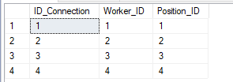

alter table [Worker_Change] add [Date_Time_Create_Emp_Chg] [datetime] null default(getdate())

insert into [Worker_Change] ([Worker_Change_Number],[Connection_ID])

values ('0001', 1),

('0002', 2),

('0003', 3),

('0004', 4)

go

select * from [Worker_Change]

order by [ID_Worker_Change]

go

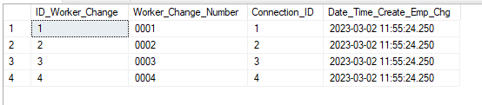

alter table [Delivery] alter column [Date_Create_Delivery] [date] null

go

alter table [Delivery] add constraint [DT_Date_Create_Delivery] default(getdate()) for [Date_Create_Delivery]

go

alter table [Delivery] alter column [Time_Create_Delivery] [time] null

go

alter table [Delivery] add constraint [DT_Time_Create_Delivery] default(getdate()) for [Time_Create_Delivery]

go

insert into [Delivery] ([Integrity], [Delivery_Number], [Maker_ID], [Warehouse_ID] )

values ('Good','0001',1,5),

('Good','0002',2,4),

('Good','0003',3,3),

('Very Good','0004',1,2)

go

select * from [Delivery]

order by [ID_Delivery]

go

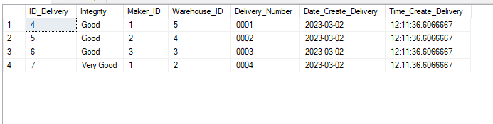

alter table [Sale_Check] alter column [Date_Create_Check] [date] null

go

alter table [Sale_Check] add constraint [DT_Date_Create_Check] default(getdate()) for [Date_Create_Check]

go

alter table [Sale_Check] alter column [Time_Create_Check] [time] null

go

alter table [Sale_Check] add constraint [DT_Time_Create_Check] default(getdate()) for [Time_Create_Check]

go

insert into [Sale_Check] ([Sale_Check_Number], [Deposited_Amount], [Whith_VAT],

[Whithout_VAT], [Payment_Type_ID], [Worker_Change_ID], [Client_Card_ID])

values ('0001', 1000, 900, 800, 1, 4, 1),

('0002', 900, 800, 700, 2, 3, 2),

('0003', 800, 700, 600, 3, 2, 3),

('0004', 700, 600, 500, 4, 1, 4)

go

select * from [Sale_Check]

order by [ID_Sale_Check] ASC

go

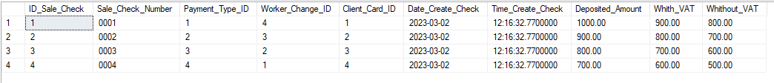

insert into [Inventory] ([Inventory_Name], [Delivery_ID], [Condition])

values('винтовка', 4, 'хорошее'),

('пистолет', 5, 'хорошее'),

('перчатки', 6, 'хорошее'),

('бронежилет', 7, 'хорошее')

go

select * from [Inventory]

order by [ID_Inventory] ASC

go

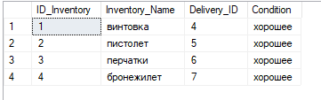

insert into [Service] ([Price_Service], [Service_Name], [Compound],

[Vendor_Code], [Type_Service_ID], [Inventory_ID])

values (2000,'Перестрелка','Перестрелка между 2 командами','F753273-76336',1,4),

(3000,'Захват флага','Захватить флаг и отнести его на свою базу','R452677-43467',2,3),

(4000,'Гонка вооружения','Опередить соперника','Y762004-22787',3,2),

(2000,'Перестрелка','Перестрелка между 2 командами','U632206-25453',4,1),

(4000,'Гонка вооружения','Опередить соперника','L653573-54373',1,1)

go

select 'Производитель инвентаря: '+[Maker_Name]+', страна: '+[Country_Name] as "Данные производителя", [Vendor_Code]

as "Артикул",'Название услуги: '+[Service_Name]+', цена за шт.: '+CONVERT([varchar] (100),

[Price_Service])+' руб., вид услуги: '+[Type_Service_Name]+', описание - "'+[Compound] as "Данные услуги" from [Service]

inner join [Type_Service] on [Type_Service_ID] = [ID_Type_Service]

inner join [Inventory] on [ID_Inventory] = [Inventory_ID]

inner join [Delivery] on [ID_Delivery] = [Delivery_ID]

inner join [Maker] on [ID_Maker] = [Maker_ID]

inner join [Country] on [ID_Country] = [Country_ID]

order by [Price_Service] ASC

go

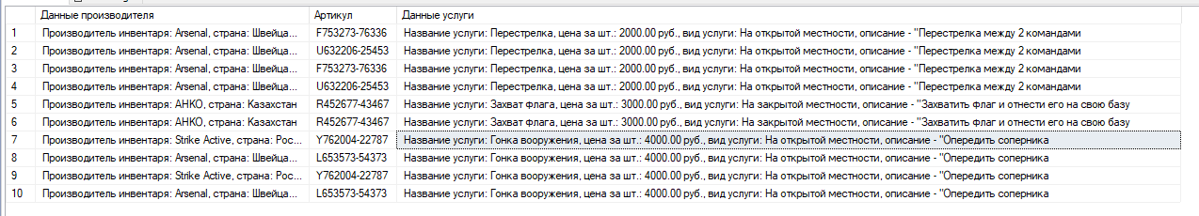

insert into [Sale_Check_View] ([Sale_Check_View_Amount], [Sale_Check_ID], [Service_ID])

values (1, 1, 1),

(5, 2, 2),

(2, 3, 3),

(1, 4, 4),

(3, 1, 5)

Go

select * from [Sale_Check_View]

order by [ID_Sale_Check_View] ASC

go

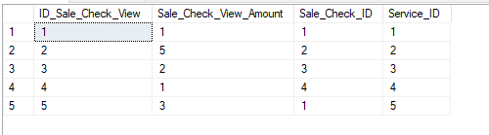

insert into [Cancellation_View] ([Cancellation_ID], [Service_ID])

values (1,4),

(2,3),

(3,2),

(4,1)

go

select * from [Cancellation_View]

order by [ID_Cancellation_View] ASC

go

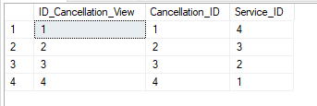

insert into [Service_View] ([Service_Amount], [Treaty_ID], [Service_ID])

values (1000, 1, 4),

(1200, 2, 3),

(900, 3, 2),

(2100, 4, 1)

go

select * from [Service_View]

order by [ID_Service_View] ASC

go

